**Giraffe - Wooden Animal Wall Mount**

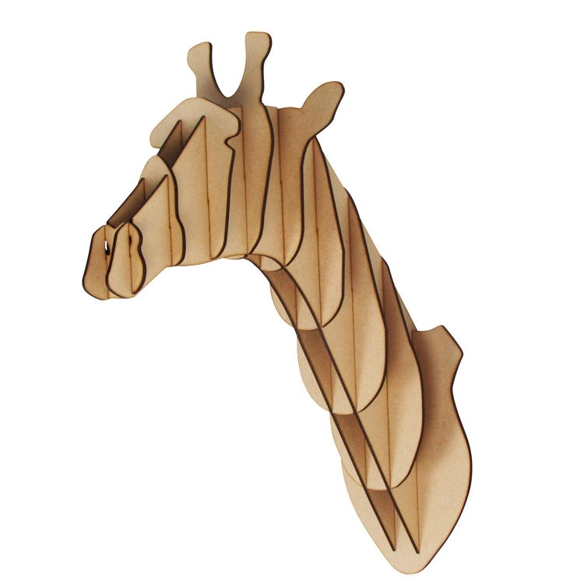The Giraffe Wooden Animal Wall Mount is a unique and eye-catching piece that brings the elegance of the African savanna into your home. Crafted from high-quality wood, this mount features a finely detailed giraffe head, with elongated features and intricate carvings that highlight the animal's graceful silhouette. The natural wood finish adds a warm, organic touch to any room, blending seamlessly with various interior styles, from rustic to contemporary. Perfect for animal lovers or those seeking distinctive, nature-inspired decor, this giraffe wall mount serves as a bold statement piece while offering a refined, artistic look.